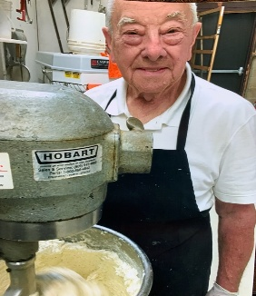 | NAT’S NEWS  Westmont Bagel’s Latest news and bulletin updates
Anthony Stagliano, Jr.  Why Westmont Bagel Customers Keep Coming Back After 30 Years: It’s All About the Staff!  For three decades, Westmont Bagel has been a beloved staple in the community, attracting loyal customers who return time and again for their favorite bagels. While the delicious offerings play a significant role, there’s an undeniable secret to their success: the incredible staff. Let’s explore how the dedicated team at Westmont Bagel creates an unforgettable experience that keeps customers coming back for more.  A Warm Welcome  From the moment you step through the doors of Westmont Bagel, you are greeted with a warm smile and a friendly “hello.” The staff members have a genuine passion for customer service, ensuring that everyone feels valued and appreciated. This welcoming atmosphere makes customers feel right at home, turning a simple bagel run into a delightful experience.  Building Personal Connections  One of the standout features of Westmont Bagel is the strong relationships that staff members build with their customers. Many patrons have been visiting for years, and the staff takes the time to remember their names, favorite orders, and even special life events. Whether it’s a birthday, graduation, or a new job, the staff at Westmont Bagel celebrates these moments with their customers, fostering a sense of community and belonging.  Expertise and Passion  The team at Westmont Bagel is not just skilled in making delicious bagels; they are also passionate about their craft. Many staff members have been with the company for years, honing their skills and knowledge of the bagel-making process. This expertise shines through every product they serve, as customers can taste the difference in the quality of their bagels. When you have a staff that truly cares about the food they serve, it elevates the entire dining experience. |  |  | 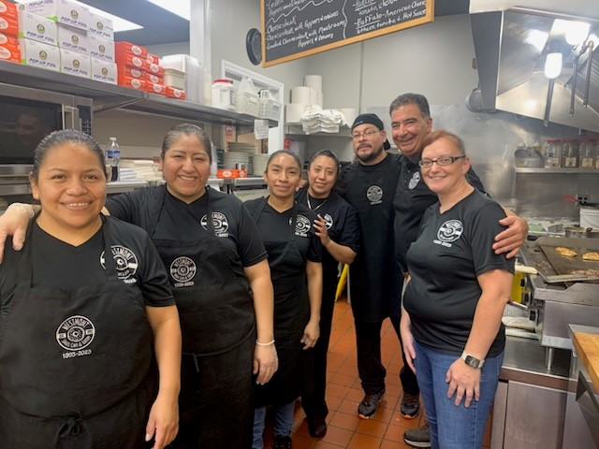
 |  |  | “When you have a staff that truly cares about the food they serve, it elevates the entire dining experience.”
A Diverse Menu with Personal Touches
While Westmont Bagel is known for its classic bagels, the staff is always eager to recommend new offerings and specials. Their enthusiasm for the menu encourages customers to try something different, whether it’s a seasonal bagel flavor or a unique cream cheese spread. Staff members are knowledgeable about the ingredients and are happy to make personal recommendations based on individual preferences, making each visit feel special. The staff at Westmont Bagel plays a crucial role in the shop's involvement in the local community. They participate in events, fundraisers, and outreach programs that strengthen community ties. Customers appreciate knowing that their favorite bagel shop is actively giving back, and it creates a shared sense of pride among both staff and patrons.
 |  |  | Over the years, Westmont Bagel has evolved to meet the changing needs of its customers, and much of this adaptability comes from the insights of the staff. They listen to feedback and are always looking for ways to improve customer experience, whether it’s through new menu items, efficient service, or accommodating special requests. The reason customers keep returning to Westmont Bagel after 30 years is clear: it’s all about the staff. Their dedication to providing exceptional service, building personal connections, and maintaining the highest quality standards creates an experience that goes beyond just enjoying a bagel. At Westmont Bagel, customers are not just patrons; they are part of a community that feels like family. | As they celebrate three decades of business, it’s evident that the heart and soul of Westmont Bagel lies within its incredible team, ensuring that customers will continue to come back for many more years to come.  